SUPREME COURT OF THE STATE OF NEW YORK COUNTY OF NASSAU  ------------------------------------------ | X
In the Matter of the Application of  FELIX PROCACCI,  Petitioner,  -against-  TOWN OF HEMPSTEAD  Respondent.  ------------------------------------------ | :  :  :  :  :  :  :  :  :  :  :  :  :  :  :  X | Index No.  615888/2018  AFFIDAVIT IN  OPPOSITION OF MOTION TO DISMISS  Justice Assigned:  Hon. Sharon M.J. Gianelli  Return Date: 01/09/2019
TO THE SUPREME COURT OF THE STATE OF NEW YORK, COUNTY OF NASSAU:
I Felix Procacci, being duly sworn, deposes and says:

- I am the Petitioner in this proceeding. Petitioner is appearing Pro Se in this matter. Petitioner makes this affidavit in opposition to the motion by the Respondent Town of Hempstead to dismiss the Petition.
- The Respondent cites two reasons for dismissing this action. First, the Petitioner does not have standing, and second, this proceeding is improperly brought pursuant to an Article 78 because Petitioner is an unaggrieved party in this litigation.
- The Petitioner disagrees with the Respondent's arguments for dismissal.
- Each of these issues were discussed in the Petition (in items 27 through 33), but the Respondent chose not to respond directly to those statements.
- The Petitioner explained in the Petition, why he believes he has standing and why an Article 78 mandamus proceeding is appropriate in this case.
- For convenience those arguments made in the Petition will be repeated and expanded here to ensure that the Respondent is cognizant of the case law cited which allows an unaggrieved Citizen-Taxpayer to challenge the Constitutionality of a local law and bring this case with an Article 78 seeking an order of mandamus
- First, the Respondent argues that the Petitioner does not have standing because he is not specially aggrieved by the ordinance referred to as the “Emergency Free Air Law” in the petition and hereon after.
- Second, the Respondent argues that an Article 78 is improper for this proceeding as follows: “Mandamus to compel does not lie in the absence of a clear legal right to the relief sought, and there is no such right, petitioner's claims not withstanding.”
- This proceeding is challenging the Constitutionally of the “Emergency Free Air Law” claiming it violates the Fourteenth amendment to the United States Constitution as well as Town and State laws.
- The following statements cite case law from the second department that shows an unaggrieved Citizen-Taxpayer does have standing to challenge the Constitutionally of a local law.

Petitioner Has Standing
- An unaggrieved Citizen-Taxpayer has standing to Constitutionally challenge a local law (see St. John's Law Review, Issue 1, Volume 39, December 1964, Number 1). Referenced portion is attached hereto as Exhibit 1.
- The Petitioner is an unaggrieved citizen-taxpayer in this matter but has standing. (see: Policeman's Benevolent Ass'n v. Board of Trustees, 21 App. Div. 2d 693, 250 N.Y.S.2d 523, 2d Dep't 1964).
- In pertinent parts, the aforementioned reference (provided in Exhibit 1), states the following regarding an unaggrieved citizen-taxpayer challenging a local law.
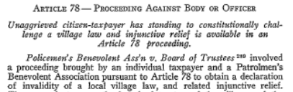
. . .
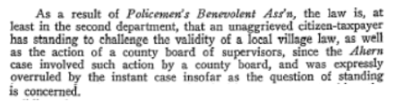
. . .
Petitioner Has Standing - continued
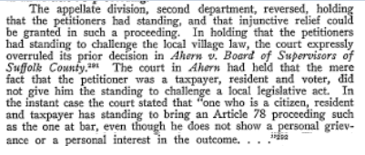

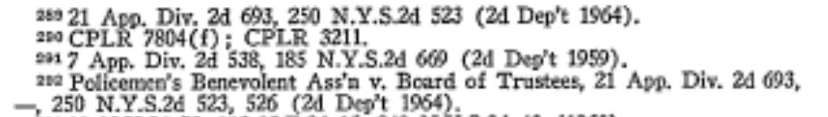

- This cases show that the second department does allow an unaggrieved citizen-taxpayer to challenge he Constitutionality of a local law and allows a citizen-taxpayer to challenge such a law pursuant to Article 78 proceeding.
- In addition, in New York State's overview of Article 78 Practice and Procedure (see : http://onlineresources.wnylc.net/FairHearingResources/docs/an_overview_of_article_78_practice_and_procedure__05-21-09_.pdf), states the following :
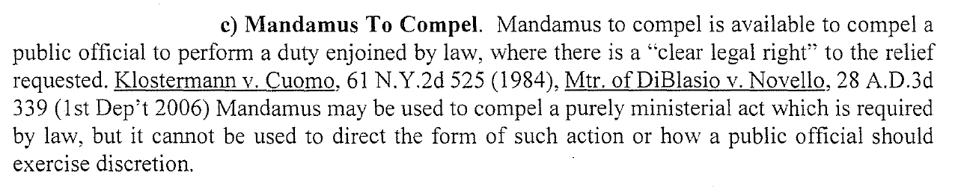
- The ministerial act requested in this proceeding is for the Respondent to rescind (repeal) the Town's “Emergency Free Air Law” since State and Local Zoning laws were violated during its enactment and the “Emergency Free Air Law” currently conflicts with both State and Local laws making it unconstitutional.
- In this proceeding, the Petitioner alleges that the Respondent, the Town of Hempstead did not follow New York State and Town law when they enacted the “Emergency Free Air Law”.
- There are no disputed questions of material fact in this case, and this has been codified by the Respondent in his Motion to Dismiss where he did not dispute any material facts stated in the Petition.
- The Respondent's Motion to Dismiss does not refute the allegation that the “Emergency Free Air Law” preempts State Law.
- The Respondent's Motion to Dismiss does not refute the allegation that the “Emergency Free Air Law” preempts New York State Zoning Law.
- The Respondent's Motion to Dismiss does not refute the allegation that the “Emergency Free Air Law” preempts its own Town Law.
- The Respondent's Motion to Dismiss does not refute the allegation that the “Emergency Free Air Law” Zoning Law was not written to regulate land usage, as required by New York State and Town Zoning Law, but was written to cut a deal to settle a law suit.
- Consequently, as stated in Ahern v. Bd. of Supervisors : “It is well settled that where there is no disputed question of material fact but only an issue of law, the relief here requested may be awarded in a mandamus proceeding” (see: Matter of Ahern v. Bd. of Supervisors, 17 Misc. 2d 164, N.Y. Misc. 1959).
- Although the Respondent does not claim the “Emergency Free Air Law” is legal in his Motion to Dismiss, the Respondent's Attorney Joseph Ra (who is also the Town Attorney) has indicated at the August 7, 2018 Public Hearing on the “Emergency Free Air Law”, that the ordinance was in compliance with the law.
- At the August 7, 2018 Town Board meeting Town Attorney Joe Ra says “we are correct on the law” when questioned about the right to regulate the price of compressed air in zoning law (see: https://youtu.be/O2WaQrBwpJQ?t=4170).
- At the August 7, 2018 Town Board meeting Town Attorney Joe Ra says in the Town's Gasoline Service Station District, Zoning law can be used to regulate pricing and handling of equipment (see: https://youtu.be/O2WaQrBwpJQ?t=4696).
- At the August 7, 2018 when the Petitioner criticizes the Town for considering the illegal “Emergency Free Air Law” Town Attorney Joseph Ra says “Just for the record Supervisor, Mr. Procacci is incorrect on the law” (see: https://youtu.be/O2WaQrBwpJQ?t=5006).
- Three times during the August 7th, 2018 Public hearing the Respondent's attorney, Joseph Ra indicated the Town's “Emergency Free Air Law” was in compliance with State and Town Laws, yet the Respondent made no effort to support this position in his Motion to Dismiss.
- The Respondent violated Town Zoning law, when it enacted the “Emergency Free Air Law” thereby exceeding its legal authority.
- The Respondent violated New York State Zoning law when it enacted the “Emergency Free Air Law”, thereby exceeding its legal authority.
- The Respondent violated New York State General Business law 396-X when it enacted the “Emergency Free Air Law”, thereby exceeding its legal authority.

WHEREFORE, Petitioner FELIX PROCACCI respectfully requests that the court reject the Respondent's Motion to Dismiss on the grounds has demonstrated the Petitioner has demonstrated it has standing to challenge the Constitutionality of a local law and also showed that an Article 78 mandamus proceeding is appropriate since there is no question of material facts, which is codified by the fact the Respondent did not deny any of the allegations in the Petition, and is brought to answer questions of law.
In addition, the Petitioner requests that said Respondent pay all costs of this legal action because the Respondent acted in bad faith when it enacted the “Emergency Free Air Law” as a compromise in settling litigation of the “Free Air Law”.

DATED: Nassau County, New York
December _____, 2018

Respectfully submitted,

_______________________
Felix Procacci
Pro Se
1165 Barnes Street
Franklin Square, New York 11010
(516) 233-1562
EXHIBIT 1
St. John's Law Review
Issue 1, Volume 39, December 1964, Number 1
Page 1 of 3
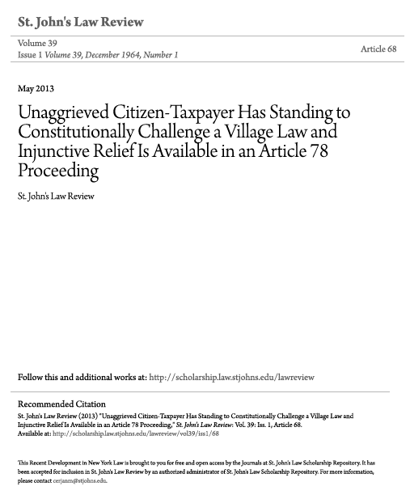
EXHIBIT 1 - continued
St. John's Law Review
Issue 1, Volume 39, December 1964, Number 1
Page 2 of 3
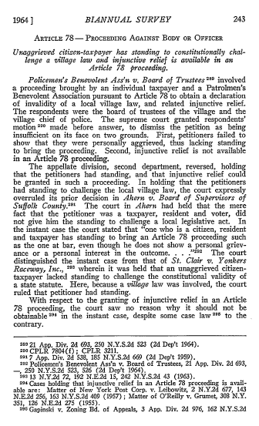
EXHIBIT 1 - continued
St. John's Law Review
Issue 1, Volume 39, December 1964, Number 1
Page 3 of 3

